Gopi Krishnan S

FSDA

ASSIGNMENT -1

SQL – ASSIGNEMENT

**Question -1**

Create the following table structure in SNOWFLAKE by creating your own warehouse. Insert some 10 rows using INSERT command (check task 3 and same way insert for all task tables) in the table by trying different values for all the columns and then check using SELECT *

Once data is loaded, performed the below task

**Task 1:**

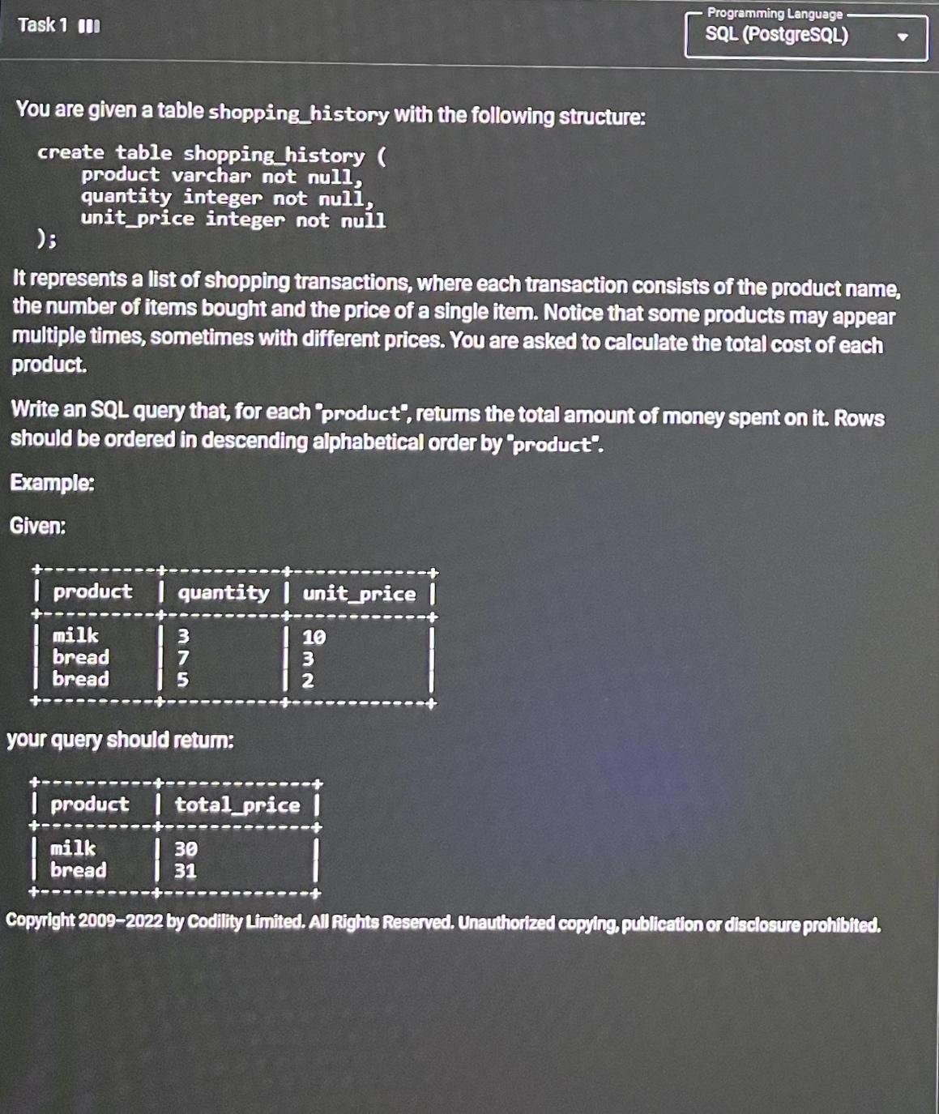

**Answer**

Queries

create database PROJECT;

use PROJECT;

create table shopping_history(

PRODUCT VARCHAR(10) NOT NULL,

QUANTITY INT NOT NULL,

UNIT_PRICE INT NOT NULL

);

SELECT * FROM shopping_history;

drop table shopping_history;

INSERT INTO shopping_history VALUES

('MILK' ,3,10),

('BREAD',7,3),

('BREAD',5,2);

select PRODUCT ,sum(QUANTITY * UNIT_PRICE) AS TOTAL_PRICE FROM shopping_history group by PRODUCT ;

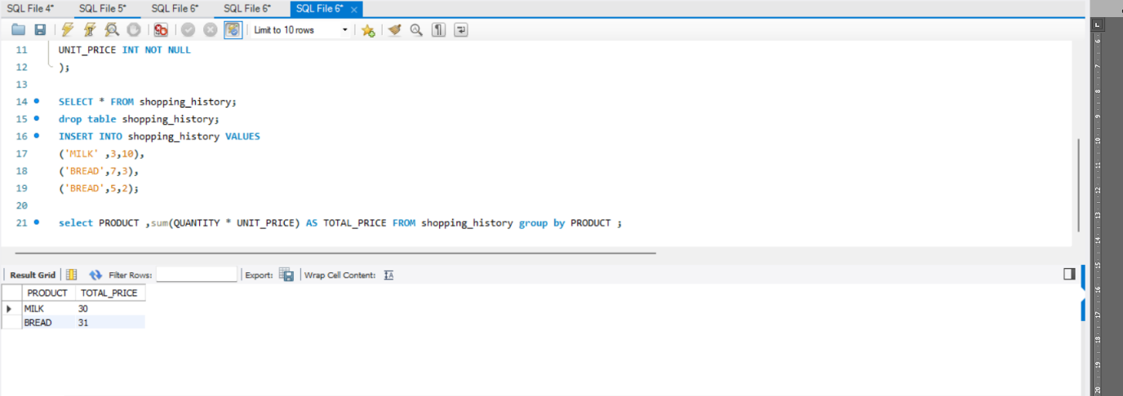

**Task -2**







**Answer**

**Part - 1**

* create table phones(

C_Name varchar(20) not null unique,

phone_number varchar(20) not null unique);

* create table calls(

id int not null unique,

caller varchar(10) not null ,

callee varchar(10) not null ,

duration int not null

);

* insert into phones values('Jack', '1234'),('Lena', '3333'),('Mark', '9999'),('Anna', '7582') ;
* insert into calls values(25, '1234','7582',8),(7,'9999','7582',1),(18,'9999','3333',4),(2,'7582','3333',3),(3,'3333','1234',1),(21,'3333','1234',1) ;
* select a.C_Name

from phones a

inner join

(select caller , sum(duration) as SM from (select a.id, a.caller, a.duration from calls a union select b.id,b.callee, b.duration from calls b) as T group by caller) as TT

on a.phone_number = TT.caller

where TT.SM >=10

order by C_Name ;

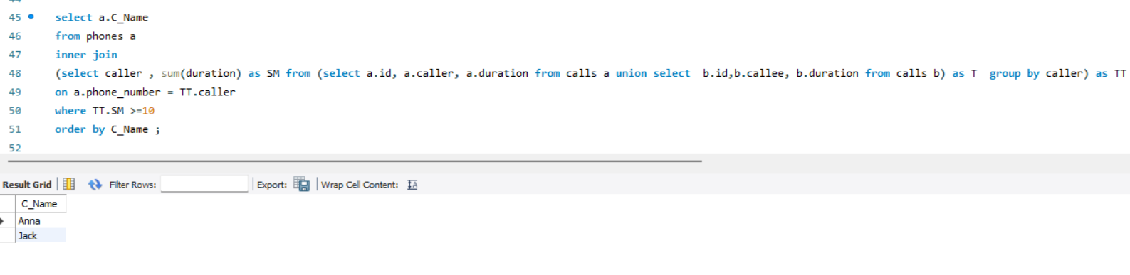

**Part - 2**

* create table phones(

C_Name varchar(20) not null unique,

phone_number varchar(20) not null unique);

* create table calls(

id int not null unique,

caller varchar(10) not null ,

callee varchar(10) not null ,

duration int not null

);

* insert into phones values('John', '6356'),('Addison', '4315'),('Kate', '8003'),('Ginny', '9831') ;
* insert into calls values(65, '8003','9831',7),(100,'9831','8003',3),(145,'4315','9831',18);
* select a.C_Name from phones a inner join calls b on a.phone_number = b.caller order by a.C_Name;

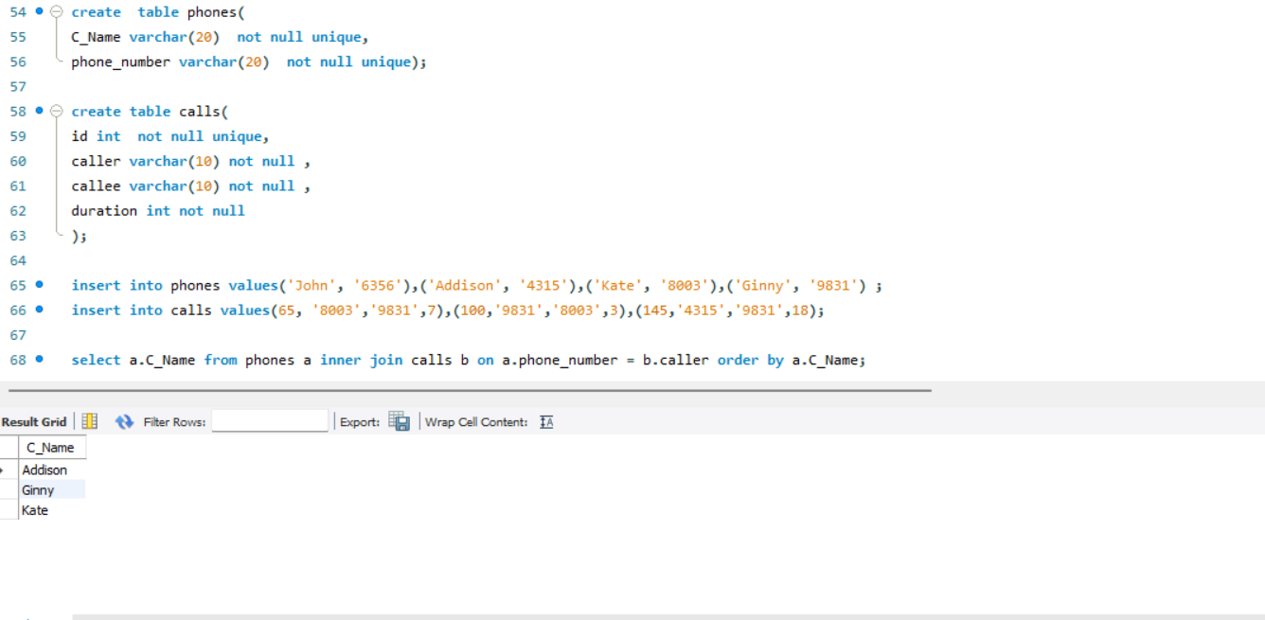

**TASK 3**

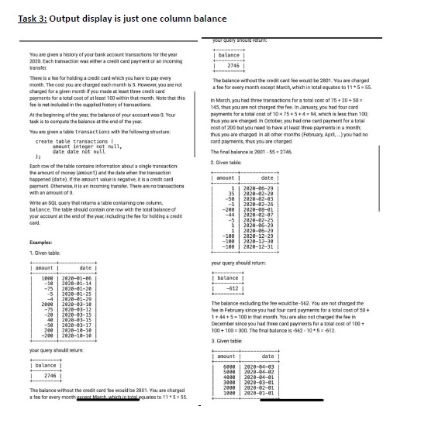

**PART-1**

* create table transactions(
  + amount integer not null,

`Date` date not null

);

* insert into transactions values

(1000,'2020-01-06'),

(-10,'2020-01-14'),

(-75,'2020-01-20'),

(-5,'2020-01-25'),

(-4,'2020-01-29'),

(2000,'2020-03-10'),

(-75,'2020-03-12'),

(-20,'2020-03-15'),

(40,'2020-03-15'),

(-50,'2020-03-17'),

(200,'2020-10-10'),

(-200,'2020-10-10');

* Delimiter &&

create function **count_month()**

returns int

Deterministic

Begin

declare cnt int;

set cnt = (select count(*)

from

(select sum(amount) as t_sum , count(amount) as t_count , month(`Date`) as c_month

from transactions

where amount like '-%'

group by month(`Date`)

having (-1*t_sum) > 100 and t_count >=3 ) as T);

return cnt;

end &&

* select sum(amount) - 5*(12 -(count_month()) ) as balance from transactions ;

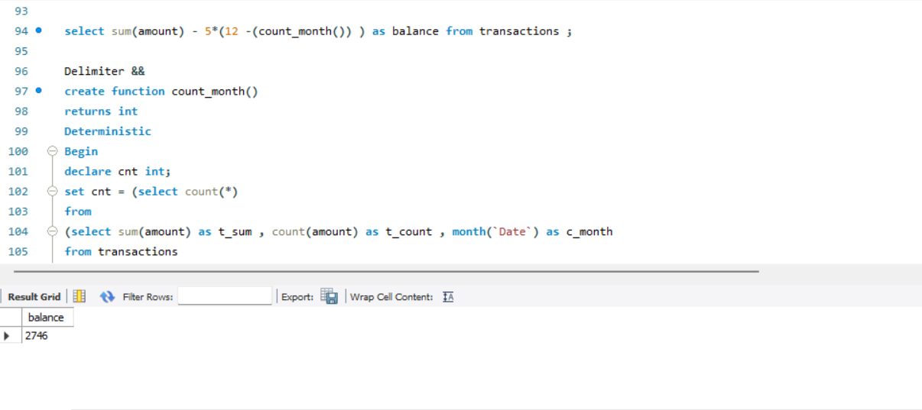

**PART-2**

* create table transactions(

amount integer not null,

`Date` date not null

);

* insert into transactions values

(1,'2020-06-29'),

(35,'2020-02-20'),

(-50,'2020-02-03'),

(-1,'2020-02-26'),

(-200,'2020-08-01'),

(-44,'2020-02-07'),

(-5,'2020-02-25'),

(1,'2020-06-29'),

(1,'2020-06-29'),

(-100,'2020-12-29'),

(-100,'2020-12-30'),

(-100,'2020-12-31');

* Delimiter &&

create function count_month()

returns int

Deterministic

Begin

declare cnt int;

set cnt = (select count(*)

from

(select sum(amount) as t_sum , count(amount) as t_count , month(`Date`) as c_month

from transactions

where amount like '-%'

group by month(`Date`)

having (-1*t_sum) >= 100 and t_count >=3 ) as T);

return cnt;

end &&

* select sum(amount) - 5*(12 -(count_month()) ) as balance from transactions ;

